Hello everyone,

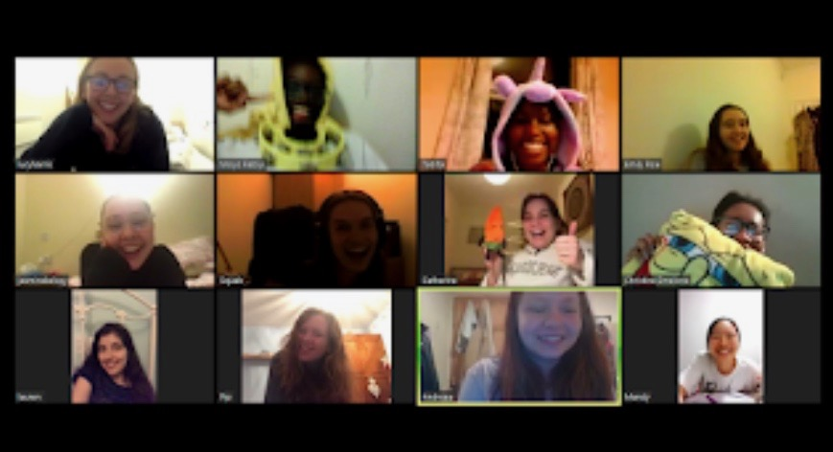
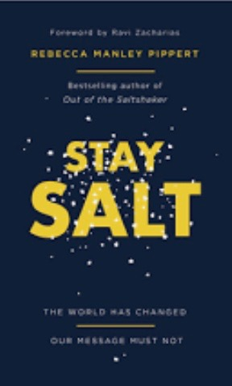
Thank you very much for all your prayers over the last few months. As you can imagine, CU has changed dramatically! With the current coronavirus situation, Sheffield Hallam University is shut and so we are unable to meet physically. However we have still been having weekly meetings via zoom call. We have also organised a few social events for our CU members, such as, many quizzes and a bingo night! It has been so encouraging that even though we cannot meet up with each other at the moment, we have still been able to have fellowship together and hear from God’s word. Additionally, we have also hosted an evangelism event, in the format of ‘Grill a Christian’, where two of our members, answered questions sent in anonymously about all aspects of the Christian faith. We staged this on Facebook Live, and our statistics read that over 1,500 people watched it! Our prayer is that this will have an impact on those who tuned in!!

Along with our weekly zoom meetings, we have set up a book club, in which we are discussing ‘Stay Salt’ by Rebecca Manley Piper, which we hope will equip us better to share the incredible news of Jesus Christ as we interact in our daily life.

Last week, CU members also took part in a 24 hour prayer event, where they would sign up to pray for an hour, focusing on praying for the future of our CU, especially the beginning of the next academic year, and to spend time in the presence of Jesus. It was so encouraging to see all our members coming together and especially to be able to fill all 24 slots, considering that we are a smaller sized CU!

For the coming academic year, we would appreciate prayer that we would be able to greet the freshers in the best way we can, and continue to spread the gospel despite any restrictions that will be in place when we return to Sheffield!!

Thank you so much for keeping us in your prayers recently, we really appreciate it, and can testify to how much God has been with us!

Sheffield Hallam CU x

